EXPT NO: 7 | IMPLEMENTATION OF A SIMPLE AUTOENCODER FOR DIMENSIONALITY REDUCTION AND FEATURE LEARNING
DATE: 02/11/2026

PRE-LAB QUESTIONS (PROVIDE BRIEF ANSWERS TO THE FOLLOWING QUESTIONS)

- Discuss the roles of the Encoder and Decoder in an Autoencoder.

- Encoder: Compresses the input data into a smaller representation called a latent representation.
- Decoder: Reconstructs the original input data from the compressed representation.

- Explain how an Autoencoder performs dimensionality reduction.

An Autoencoder reduces the dimensions of input data by passing it through a bottleneck layer containing fewer neurons. The encoder extracts important features and stores them in a smaller representation.

- Why is a bottleneck layer important in an Autoencoder architecture?

The bottleneck layer forces the model to learn only the most important features of the input data. It prevents the model from simply copying the input and helps achieve dimensionality reduction.

AIM
To implement and train a simple Autoencoder for dimensionality reduction and feature learning by compressing input data into a lower-dimensional representation and reconstructing the original data from the learned features.

SOFTWARE REQUIREMENTS
- Python
- TensorFlow / Keras / PyTorch
- Google Colab
- GitHub
- NumPy
- Matplotlib
- Pandas
- Scikit-learn

OBJECTIVES
Students will be able to:
- Understand the architecture and working of an Autoencoder.
- Identify the functions of the Encoder, bottleneck, and Decoder.
- Prepare and normalize input data for Autoencoder training.
- Build and train an Autoencoder using a suitable dataset.
- Perform dimensionality reduction through latent-space representations.
- Evaluate reconstruction performance using suitable loss metrics.
- Visualize reconstructed data and analyze the learned features.
- Document the experiment and manage the notebook using GitHub.

PROCEDURE
PART A: DATASET PREPARATION
Perform the following tasks:
- Load a suitable dataset, such as the MNIST handwritten digits dataset.
- Explore the dataset and examine sample input images.
- Identify the dimensions and data types of the input samples.
- Normalize the pixel values to a suitable range, such as 0 to 1.
- Reshape the input images into one-dimensional vectors if using a Dense Autoencoder.
- Split the dataset into training and testing datasets.
- Use the input data as both the input and target output for reconstruction.
- Display a sample of the original images.

CODE:
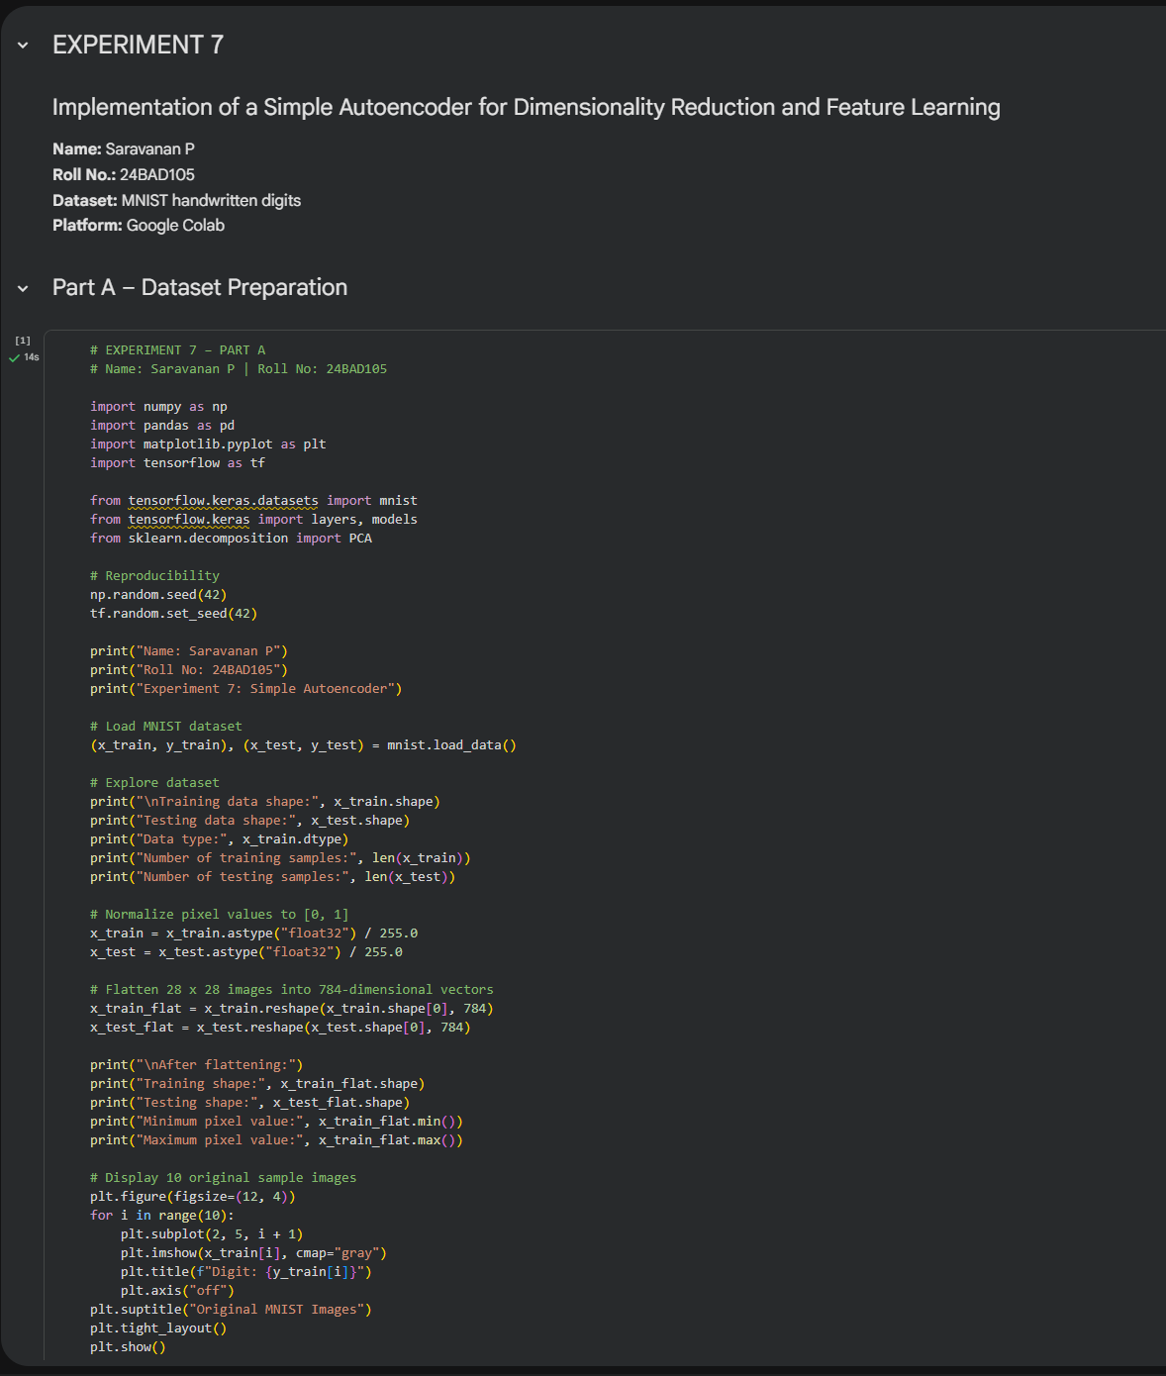

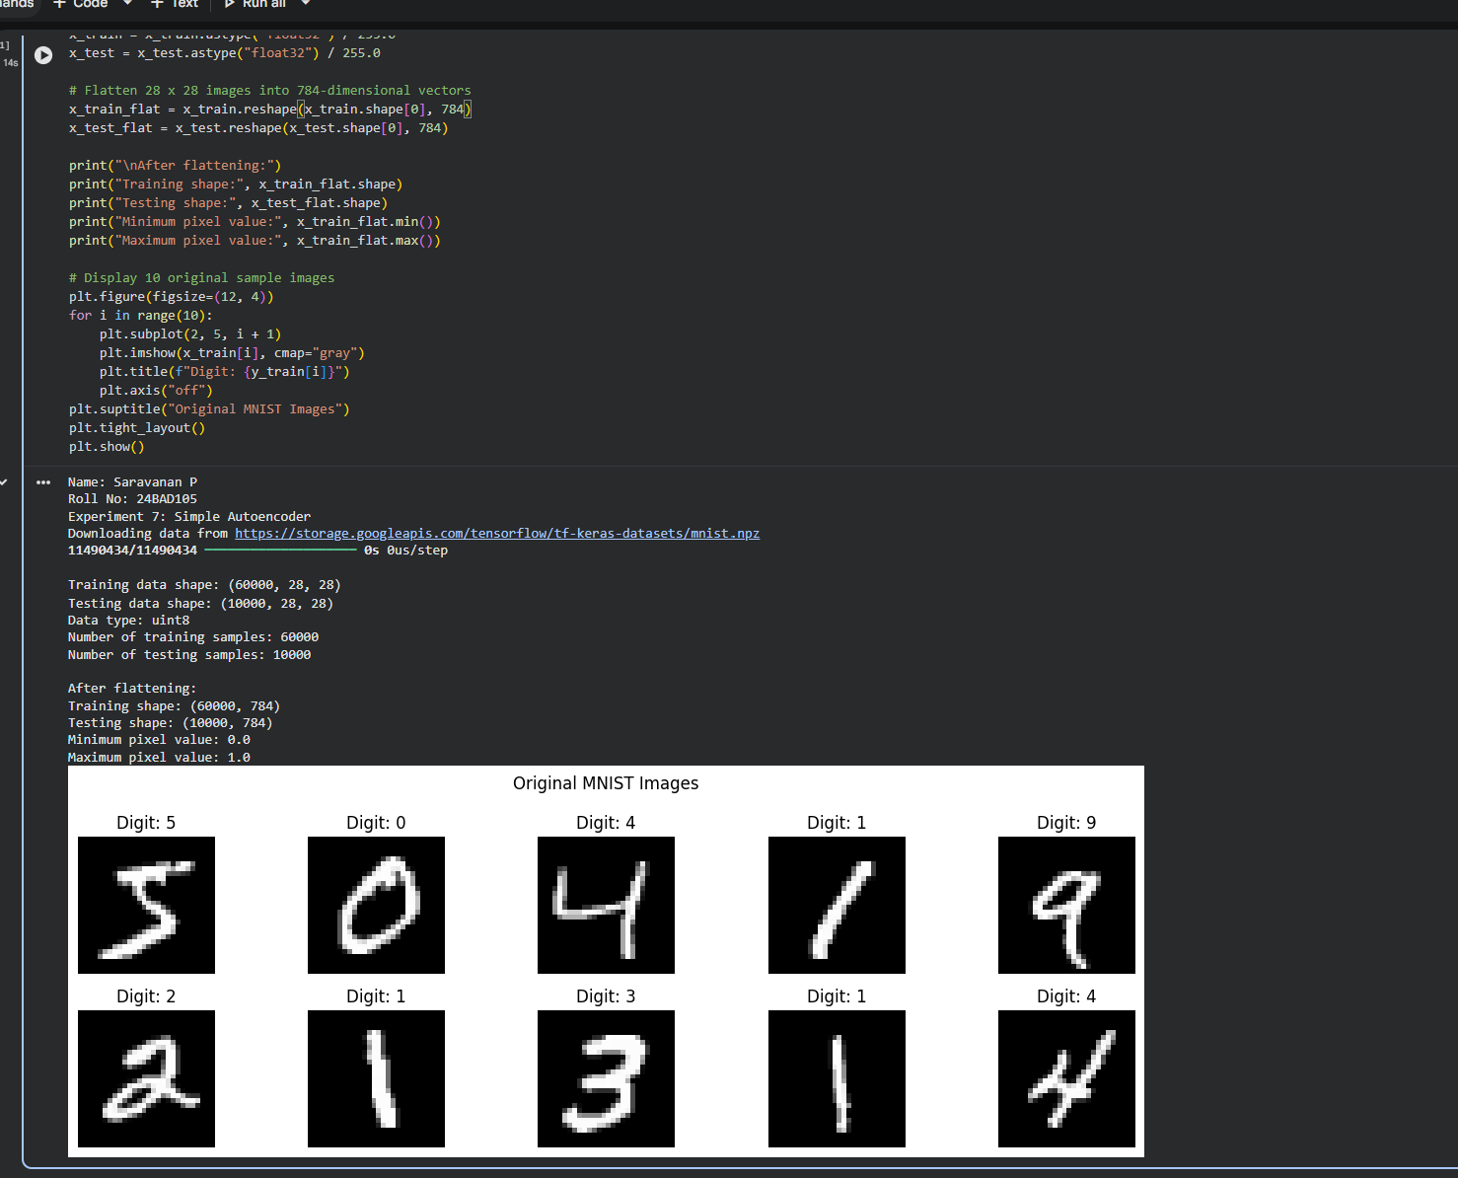

PART B: IMPLEMENTING THE AUTOENCODER MODEL
Perform the following tasks:
- Define the input layer based on the dimensions of the dataset.
- Create an Encoder using one or more Dense layers.
- Introduce a bottleneck layer with fewer neurons than the input layer to learn a compact representation.
- Create a Decoder to reconstruct the input from the bottleneck representation.
- Use a suitable activation function, such as ReLU for hidden layers and Sigmoid for normalized image reconstruction.
- Combine the Encoder and Decoder to construct the complete Autoencoder.
- Compile the model using an appropriate optimizer, such as Adam, and a reconstruction loss function, such as Mean Squared Error (MSE).
- Display the model architecture and model summary.

CODE:

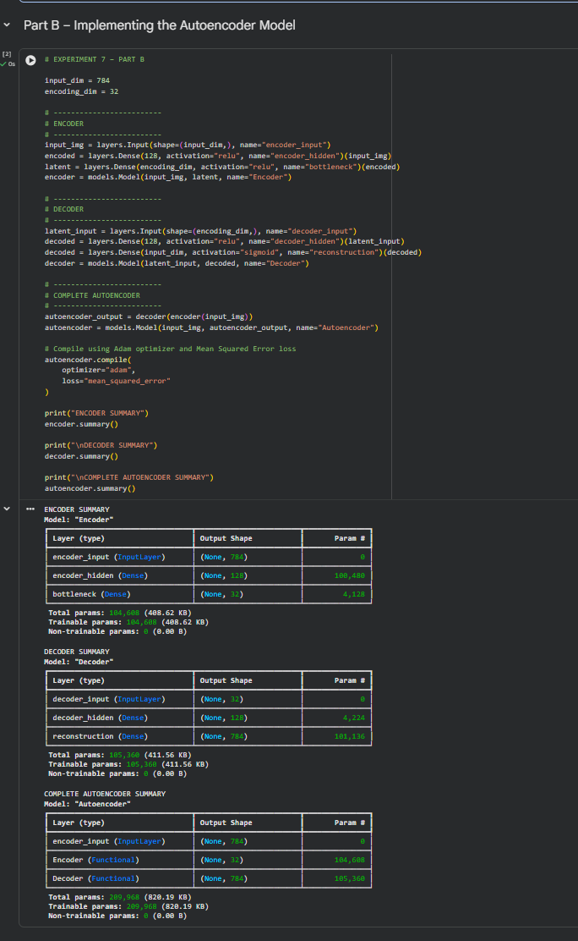

PART C: MODEL TRAINING AND PERFORMANCE EVALUATION
Perform the following tasks:
- Train the Autoencoder using the prepared training dataset.
- Use the original input samples as target outputs.
- Validate the model using validation data or the testing dataset, as appropriate.
- Record:
  - Training loss
  - Validation loss
- Evaluate the trained model using the test dataset.
- Calculate the reconstruction Mean Squared Error (MSE).
- Plot the training and validation loss against the number of epochs.
- Compare the original input images with their reconstructed outputs.

CODE:
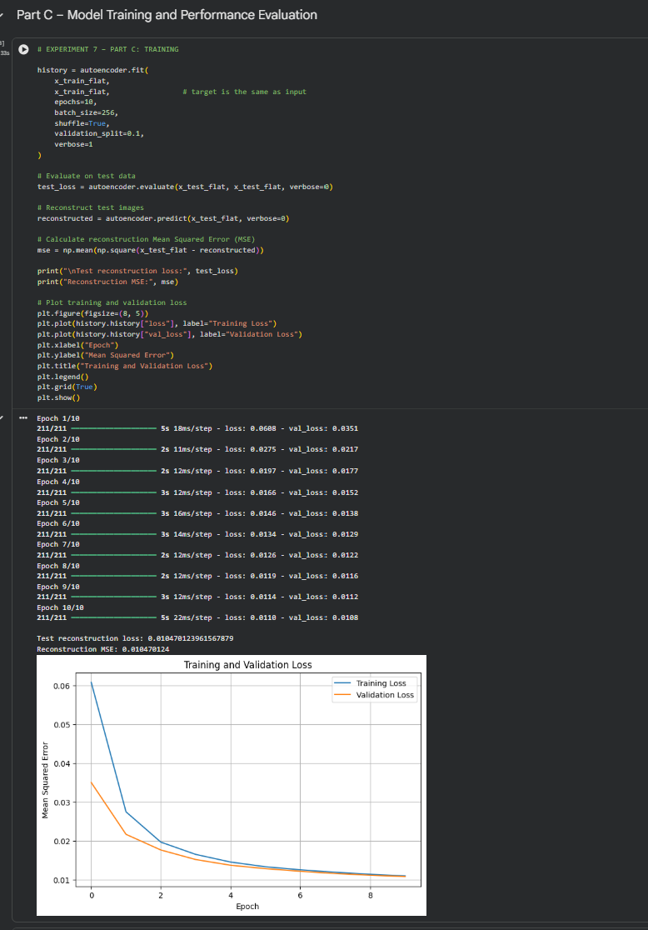

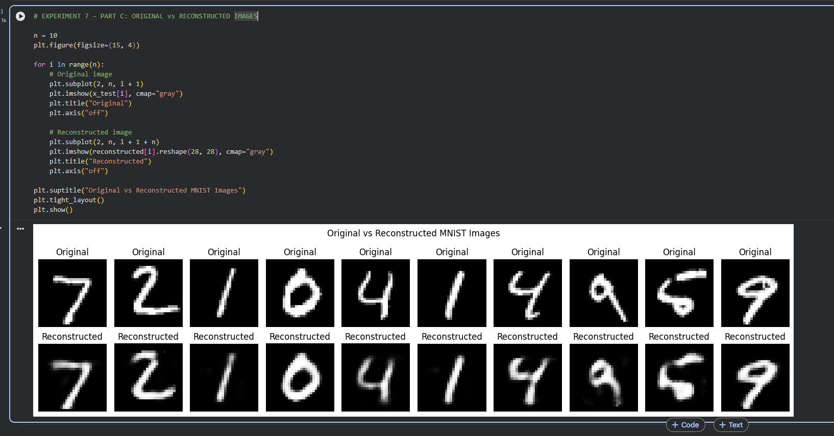

PART D: DIMENSIONALITY REDUCTION, FEATURE VISUALIZATION AND EXPERIMENT MANAGEMENT

Perform the following tasks:
- Provide new movie-review sentences as input to the trained LSTM model.
- Extract latent-space representations of test samples using the trained Encoder.
- Compare the dimensions of the original input data and compressed representations.
- Visualize the latent representations using a suitable plot.
- Reconstruct selected test samples using the Decoder and compare them with the original images.
- Record observations on dimensionality reduction and reconstruction quality.
- Document the observations and upload the notebook to GitHub.

CODE:
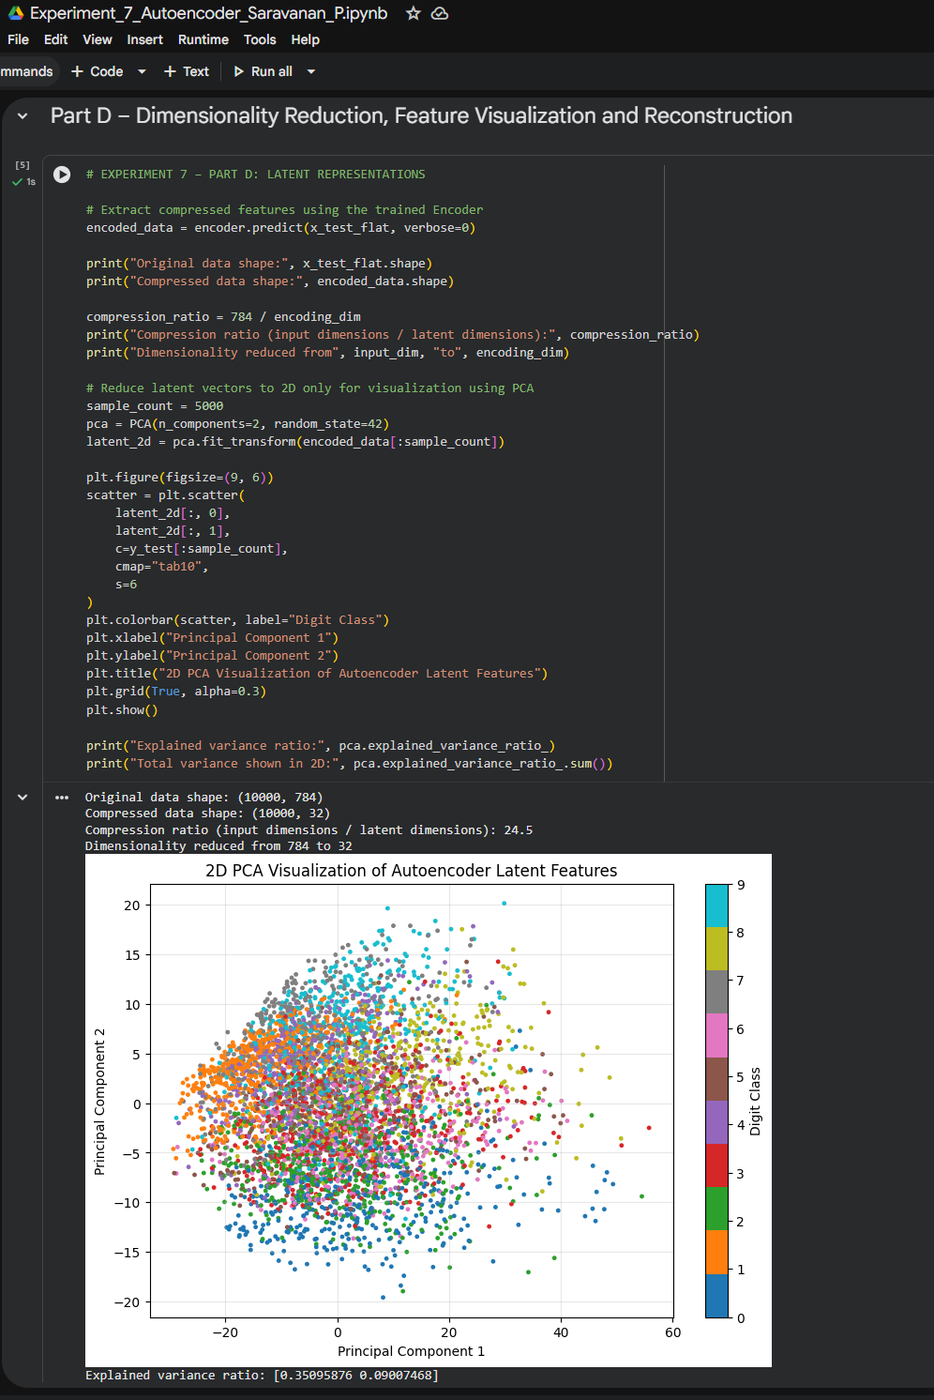

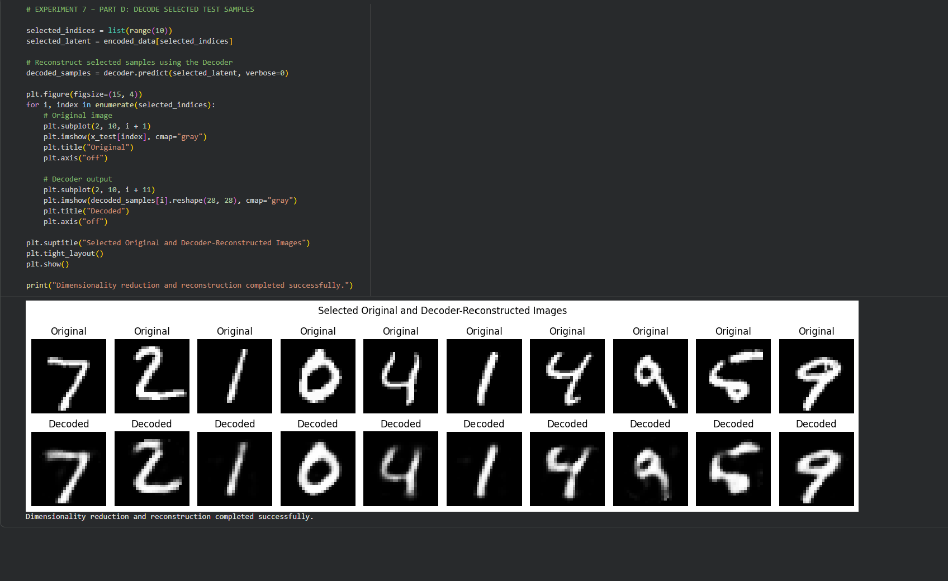

POST-LAB QUESTIONS (PROVIDE BRIEF ANSWERS TO THE FOLLOWING QUESTIONS)

- Explain the significance of reconstruction loss in training an Autoencoder.

Reconstruction loss measures the difference between the original input and the reconstructed output. It helps the Autoencoder improve its reconstruction accuracy by adjusting its weights. Lower reconstruction loss indicates better reconstruction.

- State one advantage of Autoencoders over traditional dimensionality-reduction techniques.

Autoencoders can learn complex nonlinear patterns from data, whereas traditional techniques such as PCA mainly capture linear relationships.

- Discuss two practical applications of Autoencoders apart from dimensionality reduction.

- Image Denoising: Autoencoders can remove noise from images and produce clearer images.
- Anomaly Detection: Autoencoders can identify unusual data by detecting samples with high reconstruction errors.

ASSESSMENT
Description | Max Marks | Marks Awarded
Pre Lab Exercise | 5
In Lab Exercise | 10
Post Lab Exercise | 5
Viva | 10
Total | 30
Faculty Signature

